**VISVESVARAYA TECHNOLOGICAL UNIVERSITY**

"Jnana Sangama", Belagavi-590 018



A Mini -Project Work on

**“Medical Report Management System”**

A Dissertation work submitted in partial fulfillment of the requirement

for the award of the degree

**Bachelor of Engineering**

In

**Information Science & Engineering**

Submitted by

**Shaibal Das Gupta 1AY17IS114**

**Prakhar Agrawal 1AY17IS060**

Under the guidance of

**Prof. Akshatha Ballal**

Assistant Professor



**DEPARTMENT OF INFORMATION SCIENCE & ENGINEERING**

**ACHARYA INSTITUTE OF TECHNOLOGY**

**(AFFILIATED TO VISVESVARAYA TECHNOLOGICAL UNIVERSITY, BELAGAVI.APPROVED BY AICTE, NEW DELHI)**

Acharya Dr. Sarvepalli Radhakrishnan Road, Soldevanahalli, Bengaluru-560107

**2019-20**

**DEPARTMENT OF INFORMATION SCIENCE & ENGINEERING**

ACHARYA INSTITUTE OF TECHNOLOGY

**(AFFILIATED TO VISVESVARAYA TECHNOLOGICAL UNIVERSITY, BELAGAVI.APPROVED BY AICTE, NEW DELHI)**

Acharya Dr. Sarvepalli Radhakrishnan Road, Soldevanahalli, Bengaluru-560107



**Certificate**

This is to Certify that the Mini-Project work entitled **“Medical Report Management System”** is a bonafide work carried out by **Shaibal Das Gupta (1AY17IS114) and Prakhar Agrawal (1AY17IS060)**  in partial fulfillment for the award of the degree of **Bachelor of Engineering** in **Information Science and Engineering** of the **Visvesvaraya Technological University**, Belagavi during the year 2019-20. It is certified that all corrections/suggestions indicated for Internal Assessment have been incorporated in the Report deposited in the departmental library. The Project has been approved as it satisfies the academic requirements in respect of Project work prescribed for the Bachelor of Engineering Degree.

**Prof. Akshatha Ballal Prof. Marigowda C K**

Guide HOD

**Name of the Examiners Signature with date**

**ACKNOWLEDGEMENT**

The satisfaction that accompanies the successful completion of this mini-project would be incomplete without the mention of the people who made it possible through constant guidance and encouragement.

We would take this opportunity to express our heart-felt gratitude to **Sri. B. Premnath Reddy**, Chairman, Acharya Institutes and **Dr. Prakash M R**, Principal, Acharya Institute of Technology for providing the necessary infrastructure to complete this mini-project.

We wish to express our deepest gratitude and thanks to **Prof. Marigowda C K**, Head of the Department, Information Science and Engineering.

We wish to express sincere thanks to my guide **Prof.Akshatha Ballal**, Assistant Professor, Department of Information Science and Engineering for helping us throughout and guiding us from time to time.

A warm thanks to all the faculty of Department of Information Science and Engineering, who have helped us with their views and encouraging ideas.

**ABSTRACT**

The purpose of the Medical Report Management System is to digitalize the access of patient documents by the help of computerized equipment’s and full-fledged computer software, fulfilling a patient requirements, so that valuable data/information can be stored for a longer period with easy accessing and manipulation of the same. The required hardware and software are easily available and easy to work with.

Medical Report Management System, as described above, can lead to error free, secure, reliable and fast management system. It can assist the patient to concentrate on their activities rather than to concentrate on documents keeping. Thus it will help hospital, doctor and patient in better utilization of resources. The hospital or patient can maintain computerized records without redundant entries. That means that hospital, doctor or patient need not be distracted by information that is not relevant, while being able to reach the information about an individual patient medical life.

The aim is to automate patient medical reports. This project assists patient, doctor hospital to make use of a patient medical database required by anyone of them any where. It can be used to make and hold database of a patient medical document to prevent losing. Basically the project describes how to manage for good performance and better services for the patient.

**TABLE OF CONTENTS**

**Acknowledgement i**

**Abstract ii  
1. Introduction 1**1.1 Introduction to DBMS 1  
 1.1.1 Why DBMS? 2  
 1.1.2 Database applications 2  
 1.1.3 Advantages of DBMS 3  
 1.1.4 Components of DBMS 4  
 1.1.5 Three-Schema architecture 5

**2. System Requirements 6**2.1 Hardware Requirements 6  
2.2 Software Requirements 6

**3. Design 7**3.1 ER Diagram 7  
3.2 Schema Diagram 8

**4. Implementation 9**4.1 Tables 9  
 4.1.1 Patient 9  
 4.1.2 Hospital 10

4.1.3 Doctor 10  
 4.1.4 Hos_Location 11  
 4.1.5 Test 11  
 4.1.6 Report_Paper 12  
 4.1.7 Recovery 13  
4.2 Triggers 14  
4.3 Stored Procedure 14

**5. Snapshots 15  
Conclusion & Future Enhancements 23**  
**Bibliography 24**

**TABLE OF FIGURES**

1.1 Components of Database Management System 4

1.2 Architecture of database system 5

3.1 Entity Relationship Diagram 7

3.2 Schema Diagram 8

5.1 Snapshot of choose window 15

5.2 Snapshot of login window of patient 15

5.3 Snapshot of sign up page 16

5.4 Snapshot of welcome screen 16

5.5 Snapshot of medical report viewing page from patient 17

5.6 Snapshot of searching hospital 17

5.7 Snapshot of patient personal details 18

5.8 Snapshot of login window of doctor 18

5.9 Snapshot of welcome screen of doctor 19

5.10 Snapshot of medical report viewing page from doctor 19

5.11 Snapshot of doctor personal details 20

5.12 Snapshot of login window of admin 20

5.13 Snapshot of welcome screen of hospital admin 21

5.14 Snapshot of hospital admin personal details 21

5.15 Snapshot of uploading patient test report22

**CHAPTER 1**

**INTRODUCTION**

Today the world's most forward looking automate organization like hospitals are trying to provide more reliable and accurate services in their field, offering services to the patient with all the available choices in their interest. It may be a leading many different hospital. Every Hospital nowadays is trying to computerize its activities to provide better services to its patient. With the aim of, to automate a patient documents by the help of computerized equipments and full-fledged computer software, fulfilling their requirements, so that their valuable data/information can be stored for a longer period with easy accessing and manipulation of the same.

The project, “MEDICAL REPORT MANAGEMENT SYSTEM” is also a step towards offering more or less the similar features. This system enables to manage and record the activities of medical life of a patient till his/her death.

Medical Report Management System enables the other staff to provide their services in a more systematic and efficient manner, hence improving the goodwill of concerned medical life of a patient. This helps the patient to access their documents any where at any time.

* 1. **Introduction to DBMS**

DBMS stands for **D**ata**b**ase **M**anagement **S**ystem. We can break it like this DBMS = Database + Management System. Database is a collection of data and Management System is a set of programs to store and retrieve those data. Basically DBMS is a software tool to organize (create, retrieve, update and manage) data in a database.

The main aim of a DBMS is to supply a way to store up and retrieve database information that is both convenient and efficient. By data, we mean known facts that can be recorded and that have embedded meaning. Normally people use software such as DBASE IV or V, Microsoft ACCESS, or EXCEL to store data in the form of database. A datum is a unit of data. Meaningful data combined to form information. Hence, information is interpreted data – data provided with semantics. MS. ACCESS is one of the most common examples of database management software.

Database systems are meant to handle large collection of information. Management of data involves both defining structures for storage of information and providing mechanisms that can do the manipulation of those stored information. Moreover, the database system must ensure the safety of the information stored, despite system crashes or attempts at unauthorized access.

* + 1. **Why DBMS?**
* To develop software applications in less time.
* Data Independence and efficient use of data.
* For uniform data administration.
* For data integrity and security.
* For concurrent access of data, and data recovery from crashes.
* To use user-friendly declarative query language.
  + 1. **Database applications**
* **Telecom:** There is a database to keeps track of the information regarding calls made, network usage, customer details etc. Without the database systems it is hard to maintain that huge amount of data that keeps updating every millisecond.
* **Industry:** Where it is a manufacturing unit, warehouse or distribution centre, each one needs a database to keep the records of ins and outs. For example distribution centre should keep a track of the product units that supplied into the centre as well as the products that got delivered out from the distribution centre on each day; this is where DBMS comes into picture.
* **Education sector:** Database systems are frequently used in schools and colleges to store and retrieve the data regarding student details, staff details, course details, exam details, payroll data, attendance details, fees details etc. There is a hell lot amount of inter-related data that needs to be stored and retrieved in an efficient manner.
* **Online shopping:** You must be aware of the online shopping websites such as Amazon, Flipkart etc. These sites store the product information, your addresses and preferences, credit details and provide you the relevant list of products based on your query. All this involves a Database management system.
* **Banking system:** For storing customer info, tracking day to day credit and debit transactions, generating bank statements etc. All this work has been done with the help of Database management systems.
  + 1. **Advantages of DBMS**

A DBMS manage data and has many advantages.

* **Data Independence:** Application programs should be as free or independent as possible from details of data representation and storage. DBMS can supply an abstract view of the data for insulating application code from such facts.
* **Efficient data access:** DBMS utilizes a mixture of sophisticated concepts and techniques for storing and retrieving data competently and this feature becomes important in cases where the data is stored on external storage devices.
* **Data integrity and security:**  If data is accessed through the DBMS, the DBMS can enforce integrity constraints on the data.
* **Data administration:** When several users share the data, integrating the administration of data can offer major improvements. Experienced professionals understand the nature of the data being managed and can be responsible for organizing the data representation to reduce redundancy and make the data to retrieve efficiently.
* **Providing backup and recovery:** A DBMS must provide facilities for recovering from hardware or software failures. The backup and recovery subsystem of the DBMS is responsible for recovery.
* **Permitting inferencing and actions using rules:** Some database systems provide capabilities for defining deduction rules for inferencing new information from the stored database facts.
  + 1. **Components of DBMS**

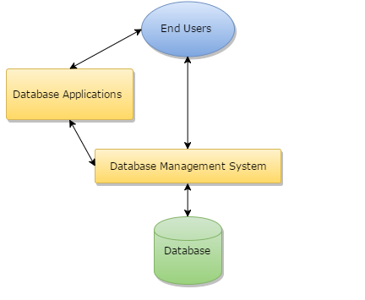

**Fig-1.1: Components of a Database Management System**

* **Users:** Users may be of any kind such as DB administrator, System developer or database users.
* **Database application:** Database application may be Departmental, Personal, organization’s and / or Internal.
* **DBMS:** Software that allow users to create and manipulate database access.
* **Database:** Collection of logical data as a single unit.
* **Database access language:** This is used to access the data to and from the database, to enter new data, update existing data, or retrieve required data from databases. The user writes a set of appropriate commands in a database access language, submits these to the DBMS, which then processes the data and generates and displays a set of results into a user readable form.
  + 1. **Three-Schema architecture**

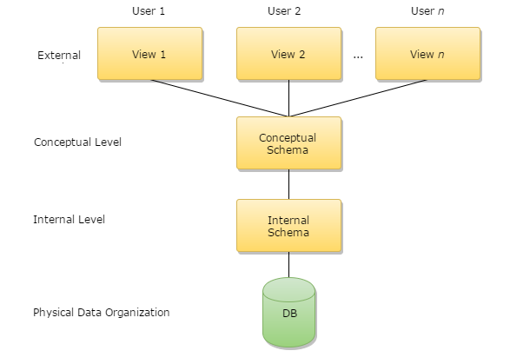

**Fig-1.2: Architecture of database system**

The levels form a three-level architecture that includes an external, a conceptual, and an internal level. The way users recognize the data is called the external level. The way the DBMS and the operating system distinguish the data is the internal level, where the data is actually stored using the data structures and file. The conceptual level offers both the mapping and the desired independence between the external and internal levels.

**CHAPTER 2**

**SYSTEM REQUIREMENTS**

**2.1 Hardware Requirements**

* **Processor:** Intel Core2 Quad @ 2.4Ghz on Windows® Vista 64-Bit / Windows® 7 64-Bit / Windows® 8 64-Bit / Windows® 8.1 64-Bit./ Windows® 10 32-Bit/ Windows® 10 64-Bit
* **RAM:** 2GB of RAM
* **Memory:** 256GB Hard drive
* **Keyboard:** MS compatible keyboard
* **Mouse:** MS compatible mouse

**2.2 Software Requirements**

* **Operating system:** Windows® Vista 64-Bit / Windows® 7 64-Bit / Windows® 8 64-Bit / Windows® 8.1 64-Bit / Windows® 10 32-Bit/ Windows® 10 64-Bit
* **Front end:** HTML, CSS, Javascript , Bootstrap, Jquery
* **Back end:** MySQL,PHP
* **Software:** Xampp
* **IDE:** Visual Studio 15.0 2017

**CHAPTER 3**

**DESIGN**

**3.1 ER Diagram**

**ER Diagram:** An **entity-relationship diagram** (**ERD**) is a data **modeling** technique that graphically illustrates an information system's relation and the relationships between those relation.

The following Fig-3.1 shows the ER Diagram for “Medical Report Management System”.Where relations are PATIENT, HOSPITAL, TEST, REPORT, DOCTOR.

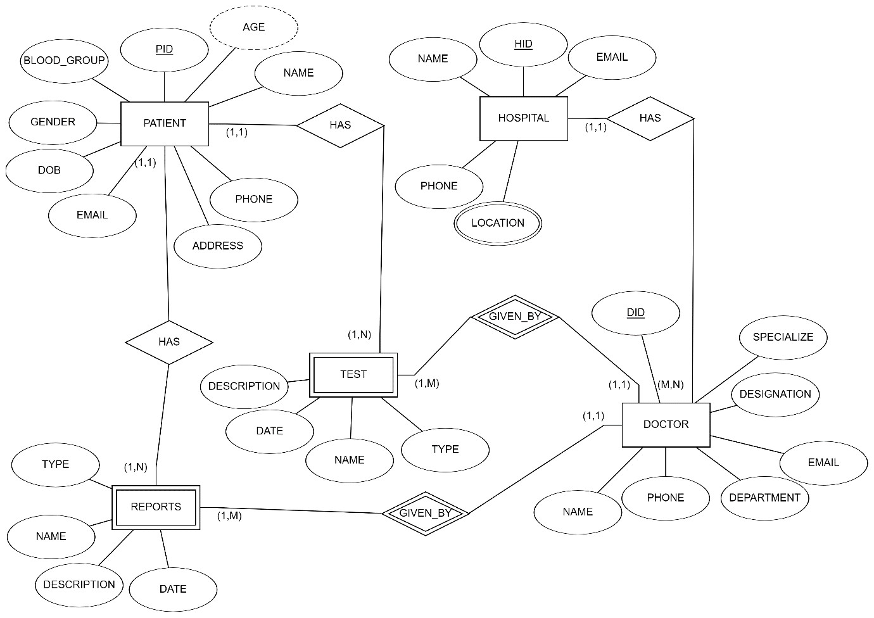

**Fig-3.1: Entity Relationship Diagram**

Fig-3.1 shows the following (1, 1) : (1, N) relation, where

**(1,1) : (1,N)**

* One patient may have many report.
* One patient may have many test.
* One doctor may give many report.
* One doctor may give many test.

**3.2 Schema Diagram**

**Schema Diagram:** An illustrative display of (most aspects of) a database schema.

**Schema Construct:** A component of the schema or an object within the schema.

The following Fig-3.2 shows the Schema Diagram for “Medical Report Management System”.Where entities are PATIENT, HOSPITAL, TEST, REPORT, DOCTOR.

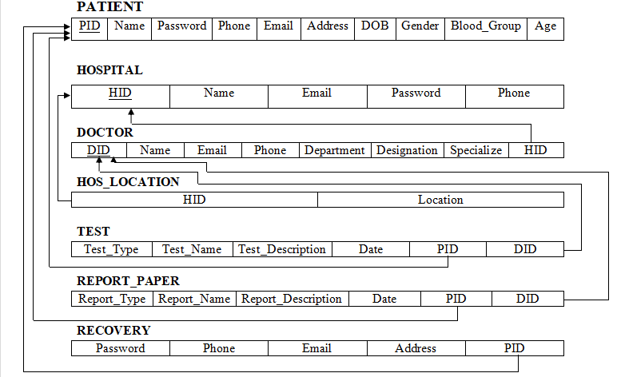

**Fig-3.2: Schema Diagram**

**CHAPTER 4**

**IMPLEMENTATION**

**4.1 Tables**

**4.1.1 Patient**

|  |  |  |  |
| --- | --- | --- | --- |
| **SNO** | **COLUMN_NAME** | **DATA_TYPE** | **DESCRIPTION** |
| 1 | PID | Integer | Primary Key |
| 2 | Name | Varchar2 |  |
| 3 | Password | Varchar2 |  |
| 4 | Phone | Integer |  |
| 5 | Email | Varchar2 |  |
| 6 | Address | Varchar2 |  |
| 7 | DOB | Date |  |
| 8 | Gender | Varchar2 |  |
| 9 | Blood_Group | Varchar2 |  |
| 10 | Age | Number |  |

CREATE TABLE PATIENT

(

PID INT NOT NULL,

PASSWORD VARCHAR NOT NULL,

NAME VARCHAR(30) NOT NULL,

EMAIL VARCHAR(50) NOT NULL,

PHONE INT NOT NULL,

ADDRESS VARCHAR(50) NOT NULL,

DOB DATE NOT NULL,

GENDER VARCHAR(7) NOT NULL,

BLOODGROUP VARCHAR(5) NOT NULL,

AGE INT NOT NULL,

PRIMARY KEY (PID)

);

**4.1.2 Hospital**

|  |  |  |  |
| --- | --- | --- | --- |
| **SNO** | **COLUMN_NAME** | **DATA_TYPE** | **DESCRIPTION** |
| 1 | HID | Integer | Primary Key |
| 2 | Name | Varchar2 |  |
| 3 | Password | Varchar2 |  |
| 4 | Email | Varchar2 |  |
| 5 | Phone | Integer |  |

CREATE TABLE HOSPITAL

(

HID INT NOT NULL,

PASSWORD VARCHAR NOT NULL,

NAME VARCHAR(30) NOT NULL,

EMAIL VARCHAR(50) NOT NULL,

PHONE INT NOT NULL,

PRIMARY KEY (HID)

);

**4.1.3 Doctor**

|  |  |  |  |
| --- | --- | --- | --- |
| **SNO** | **COLUMN_NAME** | **DATA_TYPE** | **DESCRIPTION** |
| 1 | DID | Integer | Primary Key |
| 2 | Name | Varchar2 |  |
| 3 | Email | Varchar2 |  |
| 4 | Phone | Integer |  |
| 5 | Department | Varchar2 |  |
| 6 | Designation | Varchar2 |  |
| 7 | Specialize | Varchar2 |  |
| 8 | HID | Integer | Foreign Key to Hospital |

CREATE TABLE DOCTOR

(

DID INT NOT NULL,

NAME VARCHAR(30) NOT NULL,

EMAIL VARCHAR(50) NOT NULL,

DEPARTMENT VARCHAR NOT NULL,

PHONE INT NOT NULL,

DISIGNATION VARCHAR(50) NOT NULL,

SPECIALIZE VARCHAR(50) NOT NULL,

HID INT NOT NULL,

PRIMARY KEY (DID),

FOREIGN KEY (HID) REFERENCES HOSPITAL(HID)

);

**4.1.4 Hos_Location**

|  |  |  |  |
| --- | --- | --- | --- |
| **SNO** | **COLUMN_NAME** | **DATA_TYPE** | **DESCRIPTION** |
| 1 | HID | Integer | Foreign Key to Hospital |
| 2 | Location | Varchar2 |  |

CREATE TABLE HOS_LOCATION

(

LOCATION INT NOT NULL,

HID INT NOT NULL,

FOREIGN KEY (HID) REFERENCES HOSPITAL(HID)

);

**4.1.5 Test**

|  |  |  |  |
| --- | --- | --- | --- |
| **SNO** | **COLUMN_NAME** | **DATA_TYPE** | **DESCRIPTION** |
| 1 | Test_Type | Varchar2 |  |
| 2 | Test_Name | Varchar2 |  |
| 3 | Test_Description | Varchar2 |  |
| 4 | Date | Date |  |
| 5 | PID | Integer | Foreign Key to Patient |
| 6 | DID | Integer | Foreign Key to Doctor |

CREATE TABLE TEST

(

TEST_TYPE VARCHAR(50) NOT NULL,

TEST_NAME VARCHAR(50) NOT NULL,

TEST_DESCRIPTION VARCHAR(50) NOT NULL,

DATE DATE NOT NULL,

PID INT NOT NULL,

DID INT NOT NULL,

FOREIGN KEY (PID) REFERENCES PATIENT(PID),

FOREIGN KEY (DID) REFERENCES DOCTOR(DID)

);

**4.1.6 Report_Paper**

|  |  |  |  |
| --- | --- | --- | --- |
| **SNO** | **COLUMN_NAME** | **DATA_TYPE** | **DESCRIPTION** |
| 1 | Report_Type | Varchar2 |  |
| 2 | Report_Name | Varchar2 |  |
| 3 | Report_Description | Varchar2 |  |
| 4 | Date | Date |  |
| 5 | PID | Integer | Foreign Key to Patient |
| 6 | DID | Integer | Foreign Key to Doctor |

CREATE TABLE REPORT_PAPER

(

REPORT_TYPE VARCHAR(50) NOT NULL,

REPORT_NAME VARCHAR(50) NOT NULL,

REPORT_DESCRIPTION VARCHAR(50) NOT NULL,

DATE DATE NOT NULL,

PID INT NOT NULL,

DID INT NOT NULL,

FOREIGN KEY (PID) REFERENCES PATIENT(PID),

FOREIGN KEY (DID) REFERENCES DOCTOR(DID)

);

**4.1.7 Recovery**

|  |  |  |  |
| --- | --- | --- | --- |
| **SNO** | **COLUMN_NAME** | **DATA_TYPE** | **DESCRIPTION** |
| 1 | Password | Varchar2 |  |
| 2 | Phone | Integer |  |
| 3 | Email | Varchar2 |  |
| 4 | Address | Varchar2 |  |
| 5 | PID | Integer | Foreign Key to Patient |

CREATE TABLE RECOVERY

(

EMAIL INT NOT NULL,

PASSWORD INT NOT NULL,

ADDRESS INT NOT NULL,

PHONE INT NOT NULL,

PID INT NOT NULL,

FOREIGN KEY (PID) REFERENCES PATIENT(PID)

);

**4.2 Triggers**

CREATE TRIGGER before_users_update

BEFORE UPDATE ON patient

FOR EACH ROW

insert into recovery (email, password, address, phone, pid ) values (old.email, old.password, old.address, old.phone, old.pid );

**4.3 Stored Procedures**

CREATE PROCEDURE determineAge

(IN d DATE, IN p BIGINT(12))

NOT DETERMINISTIC

BEGIN

UPDATE patient

set patient.age=FLOOR(DATEDIFF(NOW(), DATE(d))/365) where patient.pid=p;

END

**CHAPTER 5**

**SNAPSHOTS**

The following **Fig-5.1** contains three tab to choose whether loging as patient ,doctor or hospital admin.

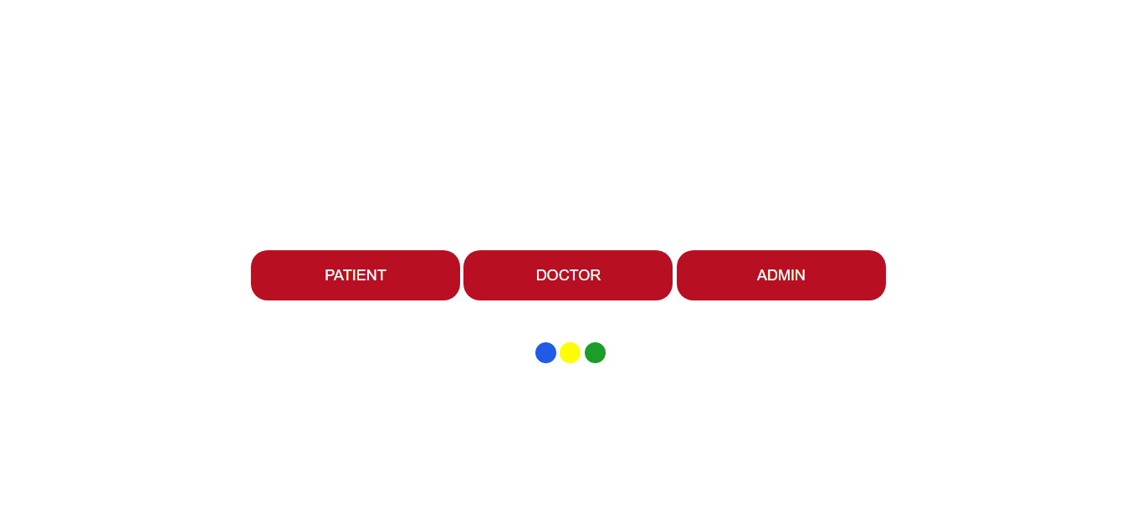

**Fig-5.1: Snapshot of choose window**

The following **Fig-5.2** contains the login screen of patient where the pid is **123443211234** and password is **asdfghjkl.**

**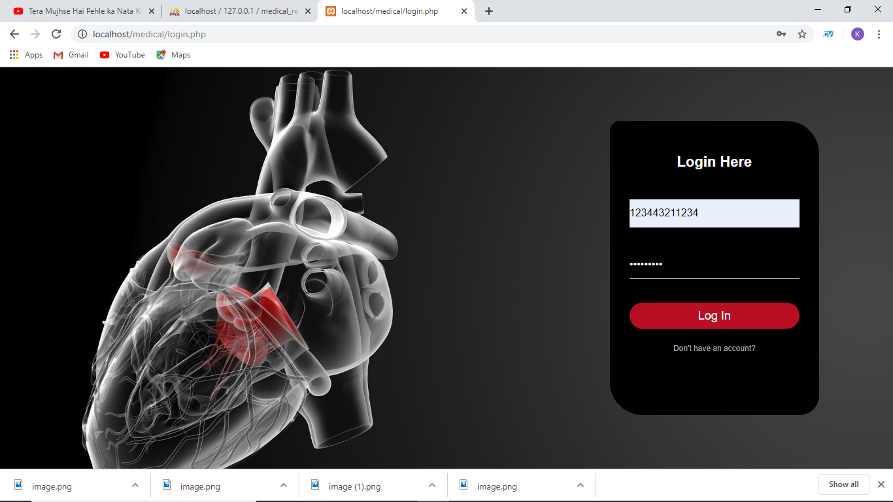  
Fig-5.2: Snapshot of login window of patient**

The following **Fig-5.3** contains sign up page of the application for new patient who does not have account.

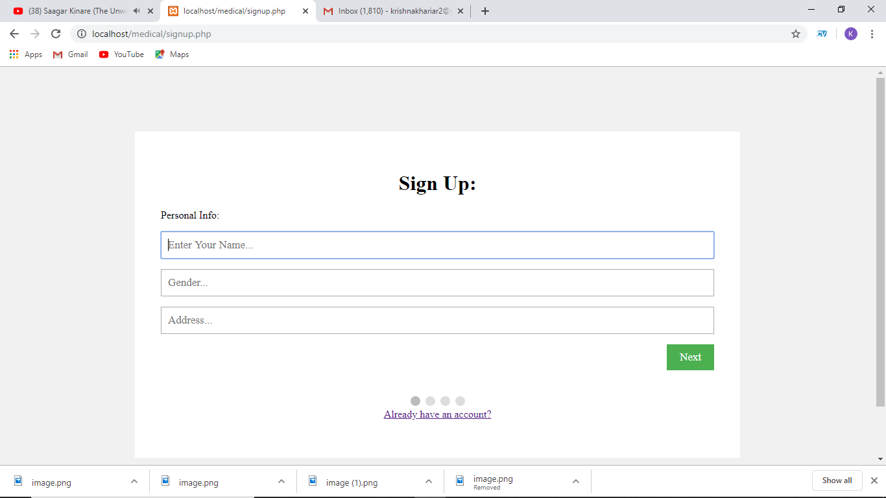

**Fig-5.3: Snapshot of sign up page**

The following **Fig-5.4** contains the welcome screen of the application for patient.

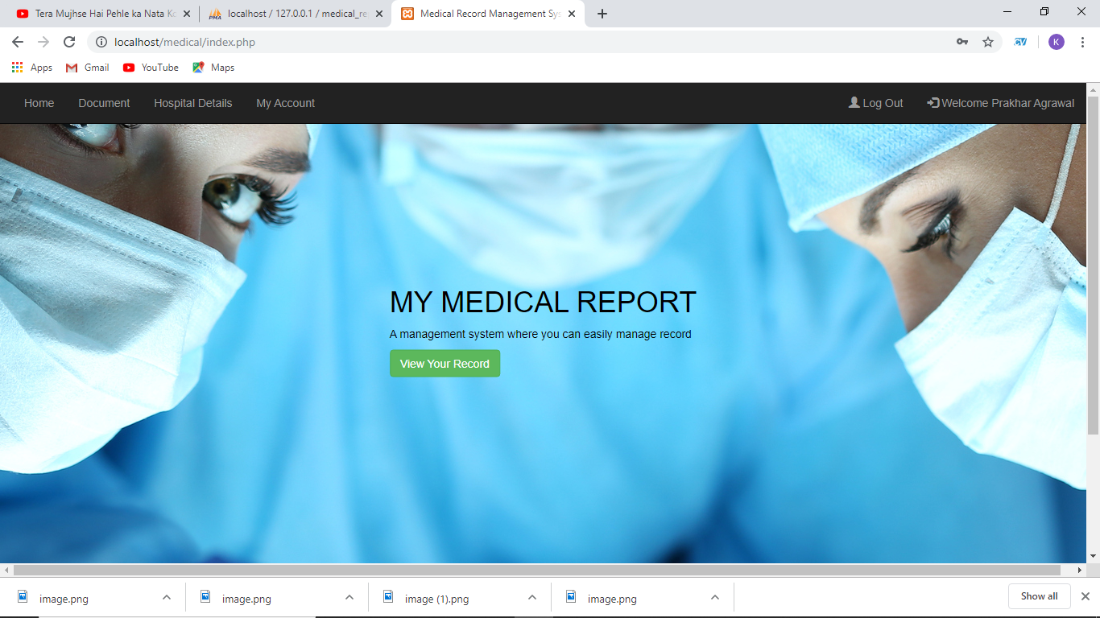  
**Fig-5.4: Snapshot of welcome screen**

The following **Fig-5.5**  contains the medical report view section where the documents of the patient will be shown to patient from the database.

**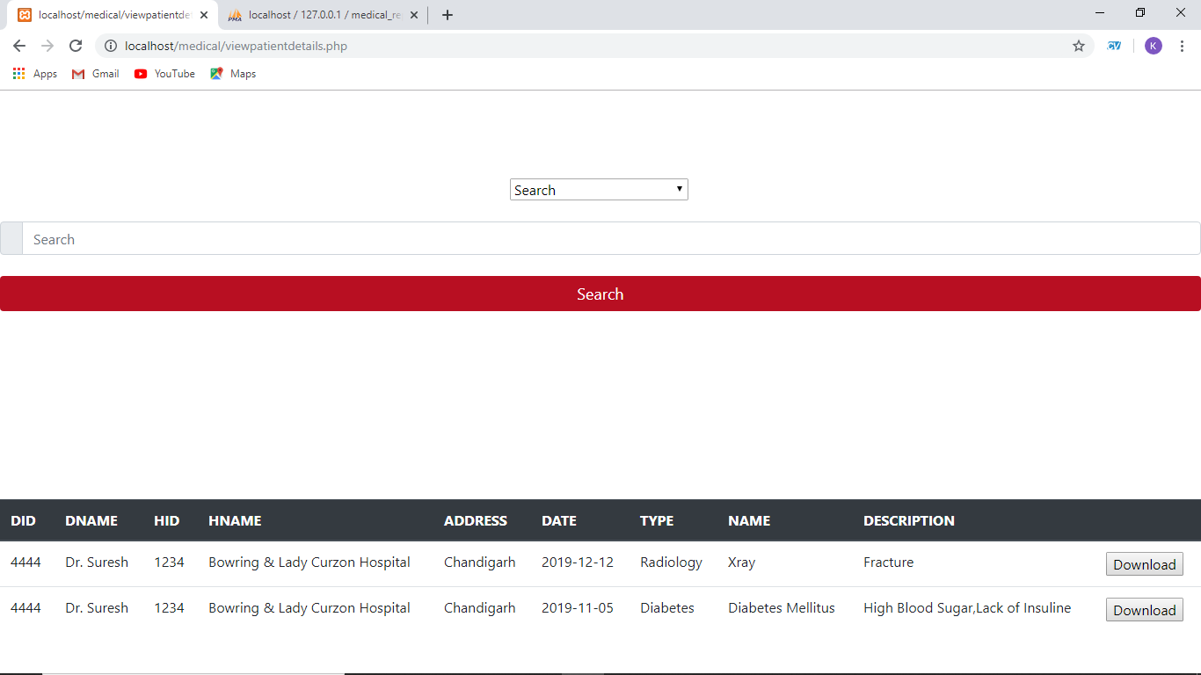  
Fig-5.5 Snapshot of medical report viewing page from patient**

The following **Fig-5.6** contains the details of hospital which is searched by patient.

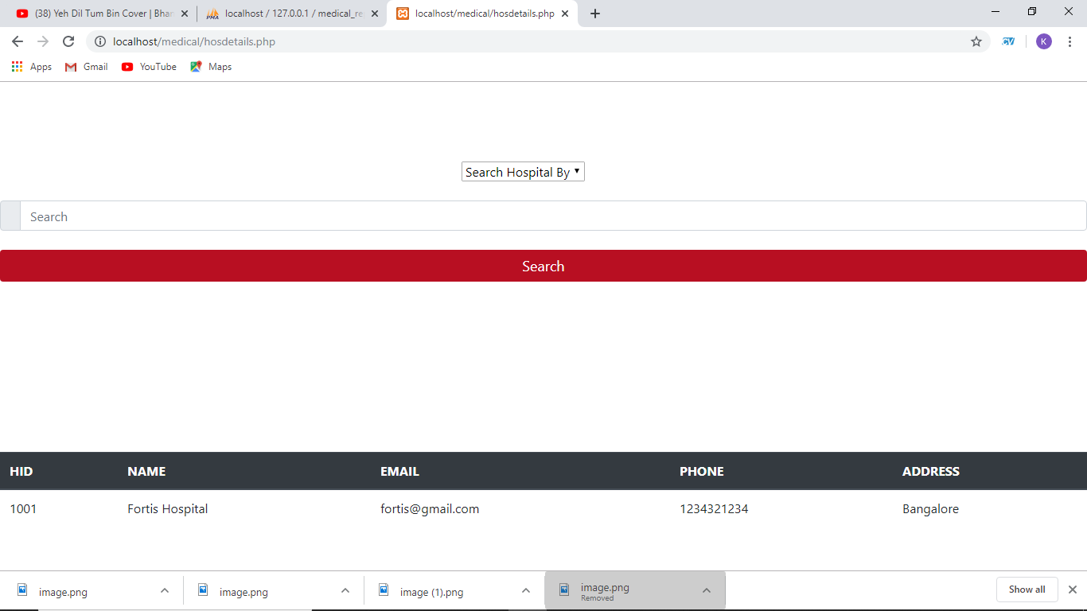

**Fig-5.6: Snapshot of searching hospital**

The following **Fig-5.7** contains the personal details of patient and there is tab for update his/her details.

**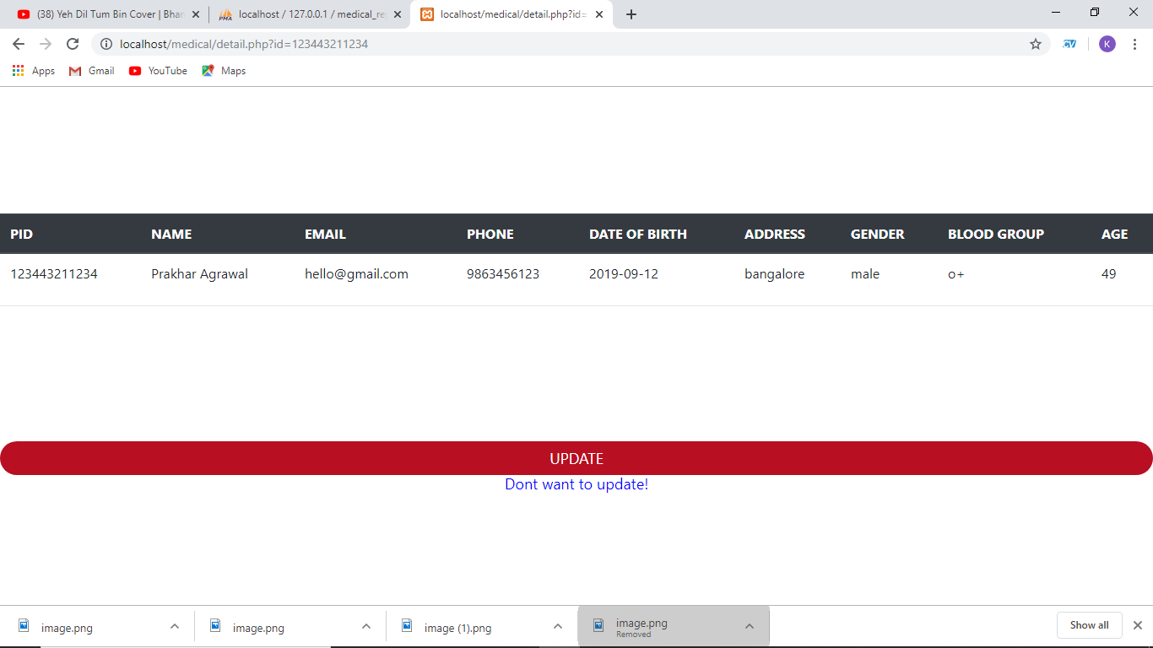  
Fig-5.7: Snapshot of patient personal details**

The following **Fig-5.8** contains the login screen of doctor where the did is **4444,** hid is 1234and password is **1234.**

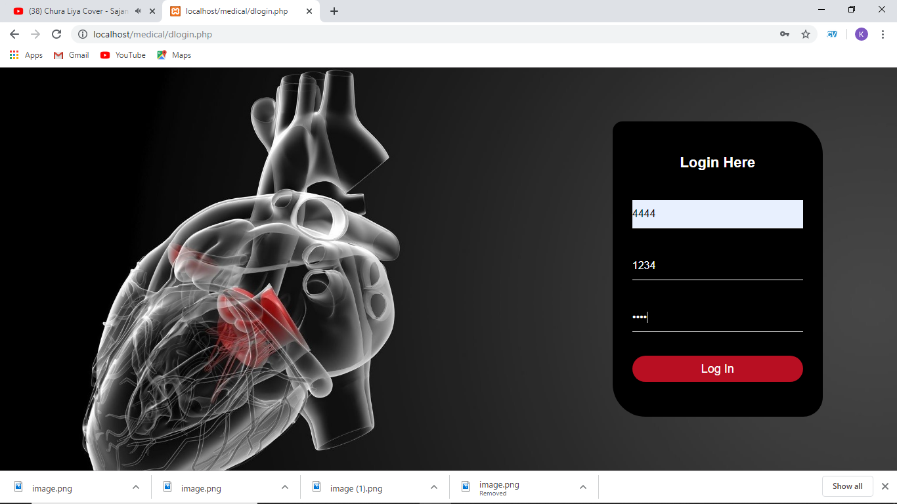

**Fig-5.8: Snapshot of login window of doctor**

The following **Fig-5.9** contains the welcome screen of the application for doctor.

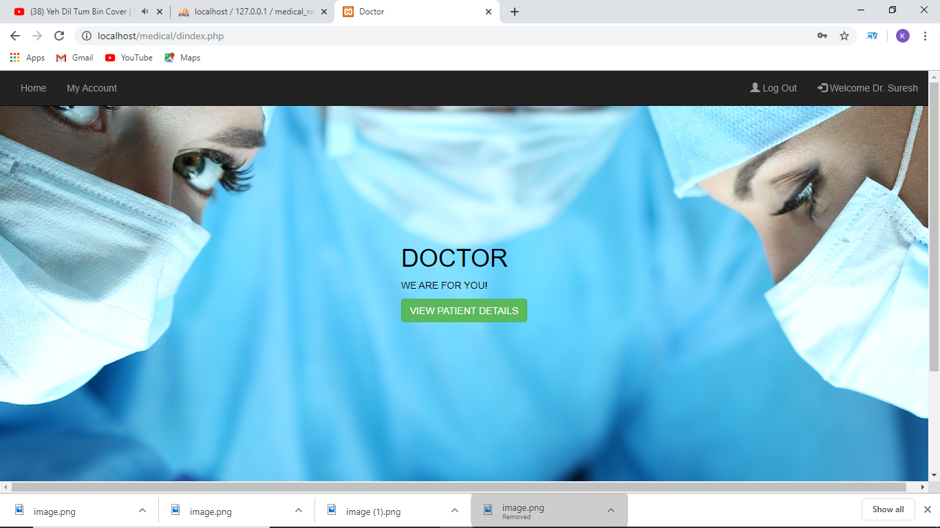

**Fig-5.9: Snapshot of welcome screen of doctor**

The following **Fig-5.10** contains the medical report view section where the documents of the patient will be shown to doctor from the database.

**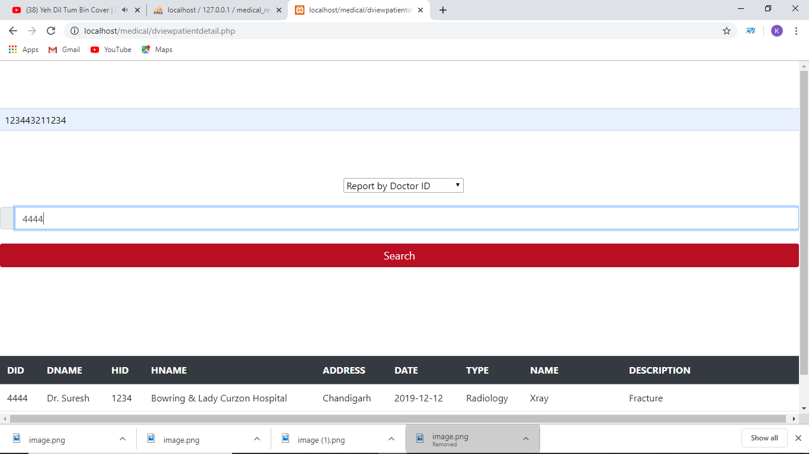  
Fig-5.10: Snapshot of medical report viewing page from doctor**

The following **Fig-5.11** contains the personal details of doctor.

**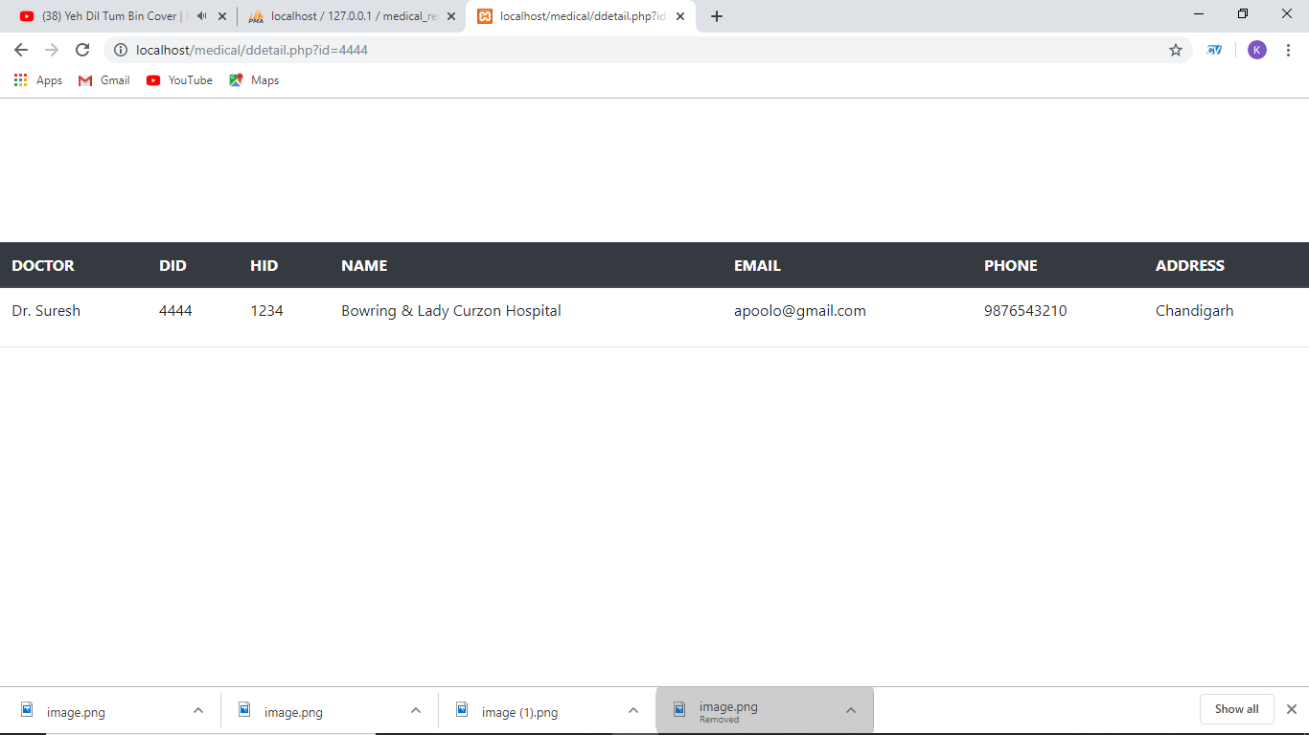  
Fig-5.11: Snapshot of doctor personal details**

The following **Fig-5.12** contains the login screen of hospital admin where hid is 1234and password is **1234.**

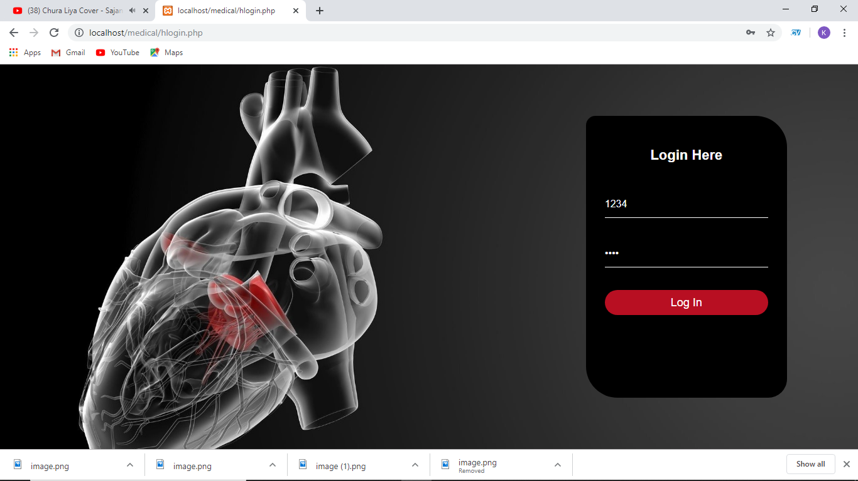

**Fig-5.12: Snapshot of login window of admin**

The following  **Fig-5.13** contains the welcome screen of the application for hospital admin.

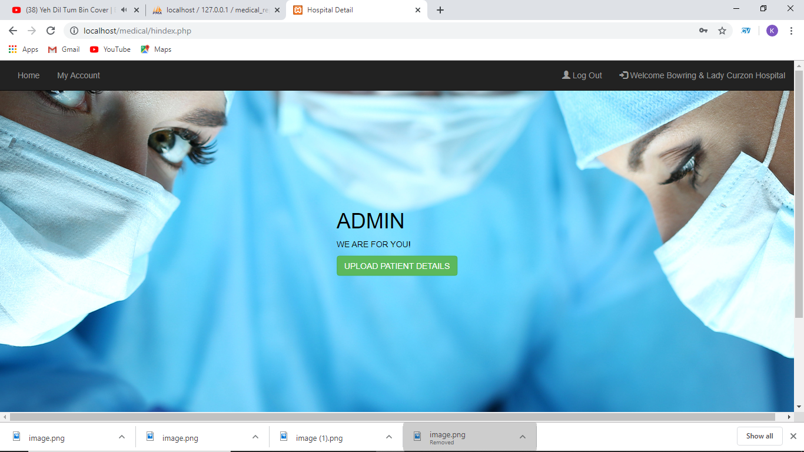

**Fig-5.13: Snapshot of welcome screen of hospital admin**

The following **Fig-5.14** contains the personal details of hospital admin.

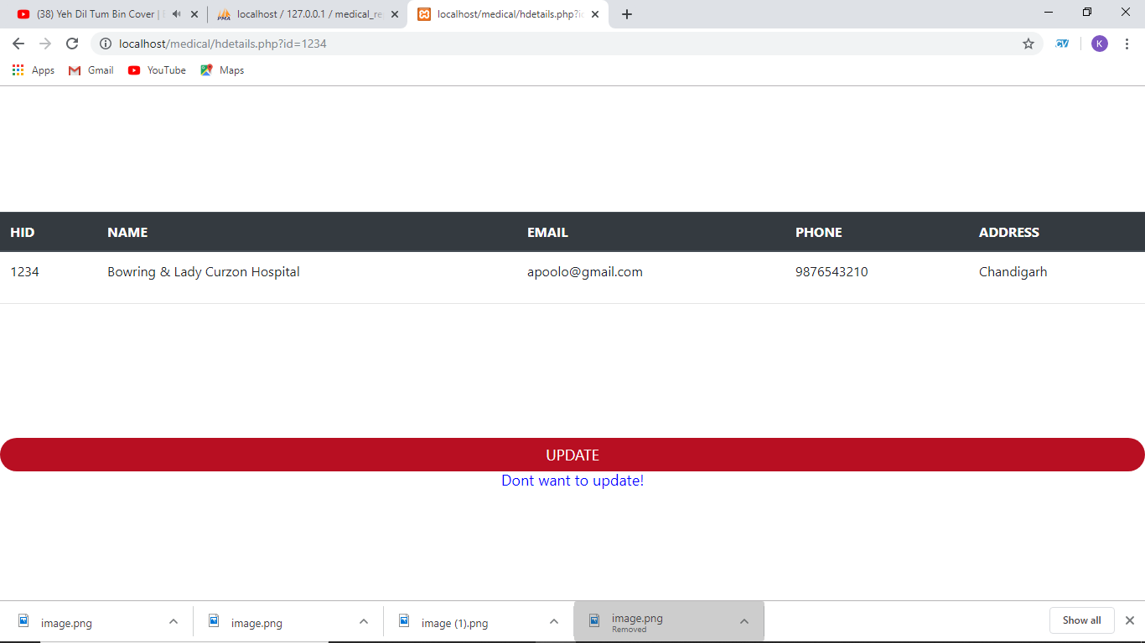

**Fig-5.14: Snapshot of hospital admin personal details**

The following **Fig-5.15** contains the view of uploading test report for pid is 123443211234.

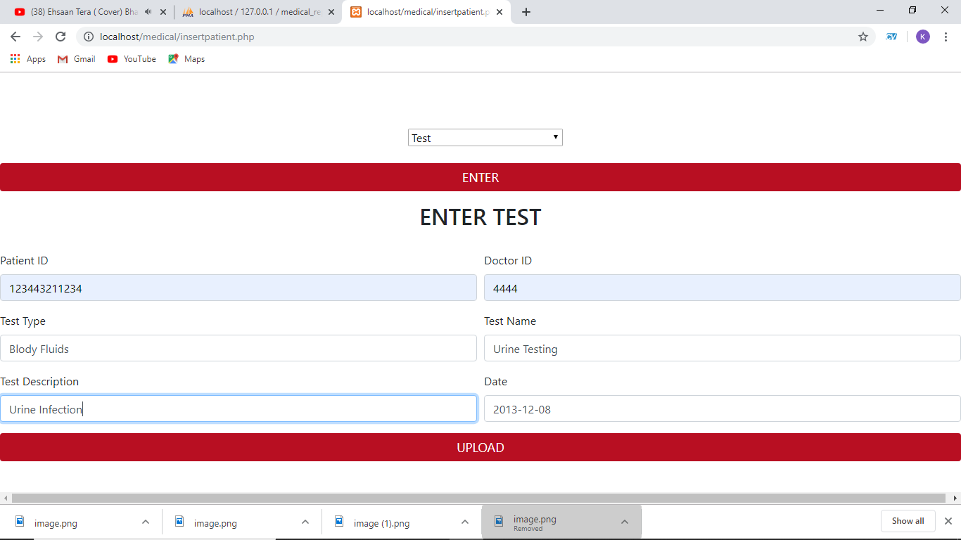

**Fig-5.15: Snapshot of uploading patient test report**

**CONCLUSION & FUTURE ENHANCEMENT**

**Conclusion**

Medical Report Management System is only a humble venture to make easy access and to prevent from losing documents. Several user-friendly coding have also adopted. This digitalize patient documents system is made to be a powerful storage in satisfying all the requirements of patient. The objective of software planning is to provide a framework that enables the patient, doctor and hospital to make easy way of viewing medical documents and should be updated regularly as the medical report of a patient progresses. This application can be used not only by patient but also hospital whether big or small that has challenges to overcome and managing the medical information.

**Future Enhancement**

In a nutshell, it can be summarized that the future scope of the project circles around maintaining information regarding:

* Patient can book appointment.
* Patient can call ambulance from nearest hospital.
* Doctor can connect with patient and diagnose them.
* Integrate multiple load balancer to distribute the loads of the system.
* Implement backup mechanism for taking backup of database on regular basis on different servers.

The above mentioned points are the enhancements which can be done to increase the applicability and usage of this project. Here we can maintain the records of patient medical reports. Enhancements can be done to maintain all the patient documents with hospital details. We have left all the options open so that if there is any other future requirement in the system by the user for the enhancement of the system then it is possible to implement them.

**BIBLIOGRAPHY**

**Web References**

1. https://www.w3schools.in/dbms/intro/

Introduction to DBMS

2. https://beginnersbook.com/2015/04/dbms-introduction/

Introduction to DBMS

3. https://dev.mysql.com/doc/

MySQL database documentation

4. https://www.php.net/docs.php

PHP connectivity documentation

**Book References**

1. Fundamentals of Database Systems, RamezElmasri and Shamkant B. Navathe, 7th Edition,

2017, Pearson

## 2. The Joy of PHP Programming: A Beginner’s Guide – by Alan Forbes

3. Murach’s MySQL